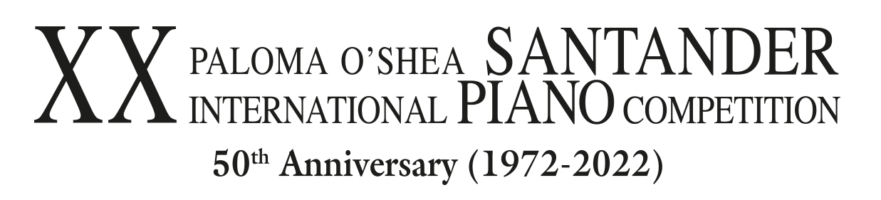

THE REGISTRATION PERIOD TO PARTICIPATE IN THE 20TH PALOMA O’SHEA SANTANDER INTERNATIONAL PIANO COMPETITION 2022 ENDS ON MONDAY 18 OCTOBER

- From 25 July to 5 August 2022, it will be held the encounter of world pianism that features the participation of a prestigious jury and great artists in the chamber and symphony orchestra performances.
- In 2022 the Santander Piano Competition will be celebrating its 50th Anniversary, and for twelve days it will turn the Cantabrian capital into a reference for international piano’s young talents.

Madrid, 21 September 2021.- All those interested in participating still have 4 weeks to register for the 20th Paloma O’Shea Santander International Piano Competition. All pianists born from 1 January 1990 onwards have the chance of signing up and being accepted to the auditions of this competition, which was founded in 1972 and is one of the most important competitions in the international arena.
Through this web form, those interested shall attach the requested documents and follow the steps outlined in the Competition Rules in order to their application to be admitted.

The pre-selection stage will take place between March and April 2022 in the cities of Madrid, Moscow, New York, and Paris. The 20 candidates will be selected from there, and they will meet in Santander on 24 July of the same year. All of them will decide on the works to be performed in compliance with the competition rules and will perform according to the order of a draw held on the morning of 25 July.

The 20th Competition has an exceptional jury composed of prestigious professionals of ten different nationalities: Joaquín Achúcarro, Spanish pianist recognised by UNESCO for his artistic work, as president; Claudio Martínez-Mehner, renowned German-Spanish soloist and piano pedagogue; Alondra de la Parra, Mexican conductor who frequently works with the world’s most prestigious orchestras; and Rena Shereshevskaya, outstanding pianist and current professor at École Normale de Musique de Paris Alfred Cortot, as vice-presidents.
The rest of the jury is made up of conductor Péter Csaba (France), and pianists Barry Douglas (United Kingdom), Akiko Ebi (Japan), Hüseyin Sermet (Turkey), and Márta Gulyás (Hungary). Gulyás will also preside over the pre-selection Jury which, at the same time, will include pianists Alexander Kandelaki from Georgia and Spanish Luis Fernando Pérez.

In this edition, the guest artists in the different stages of the Competition are the Casals Quartet, and the RTVE Symphony Orchestra, conducted by maestro Pablo Heras-Casado.

Aside from significant cash prizes, and the recording of a CD under the Naxos label for the winner, the Competition offers the winners of the most notable prizes performances in the halls that make up the international circuits, which entails a firm launching of their professional careers. In addition to the prizes granted by the Jury, for the first time, there will be a Special Award to the Best Chamber Music Performer – awarded financially and artistically with a concert with the Casals Quartet, and the Audience Award, voted by the audience in the final.

In the final round, which shall be held over two days, the six contestants that make it to this round will perform conducted by maestro Pablo Heras-Casado and accompanied by the RTVE Symphony Orchestra. Both concerts will be part of the programme for the 71st Santander International Festival.

Calendar of the 20th Edition
- Registration: From 5 July to 18 October 2021
- Pre-selection: March-April 2022 in Madrid, Moscow, New York, Paris
- First stage: From 25 to 27 July 2022. 20 participants. Recital performance
- Semi-final: From 29 July to 1 August 2022. 12 participants. Recital and chamber music performance
- Final: 3 and 4 August 2022. 6 participants. Symphony orchestra concert
- Closing gala and awards ceremony: 5 August 2022

Promotional video of the 20th Competition on: https://www.youtube.com/watch?v=P94muJCej7g

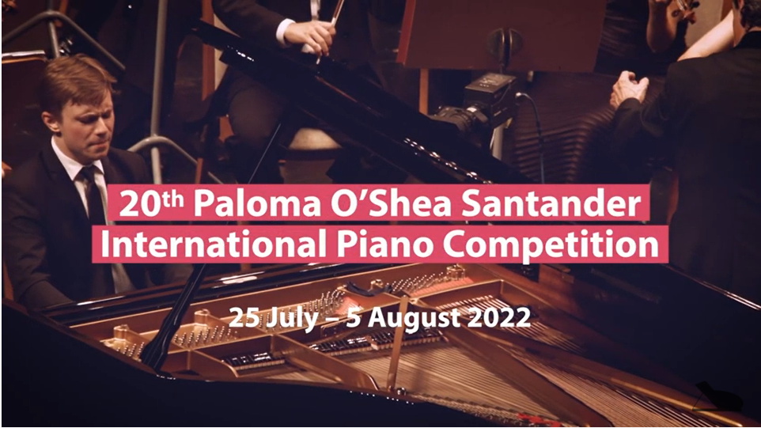

Further information:
General Secretariat of the Competition
+34 942 31 14 51 | concurso@albeniz.com

Press and Communication Department
+34 91 523 04 19 | prensaconcurso@albeniz.com

www.concursodepianodesantander.com | Facebook (@ConcursodePianodeSantander)

